**Basic Pratice of Programming Jobsheet 2**



**From:**

AL AZHAR RIZQI RIFA’I FIRDAUS

**Class:**

1 I

**Absence:**

01

**Major:**

Information Technology

**Study Program:**

Informatic Engineering

**Experiment 1: Complete Case Study On Sequence**

**Question !**

1. Mention sequentially what you do after college like experiment 1 question-1!

2. Rewrite and complete the algorithm in Experiment 1 No. 2!

3. Calculate mathematically the results of experiment 1 problem 3! What is the result?

4. If there is additional information as follows "Mr. Ahmad wants to plant a circular rose in the middle of his land. Pak Ahmad wants to maximize his land so that as much as possible there are only a few vacant lands. What is the area of Mr. Ahmad's land planted with Mawar flowers? " Rewrite the steps for making the correct algorithm!

5. After additional data about question 4, what is the area of Mr. Ahmad's land that is not planted with roses?

**Answer**

1. What I do after college.

* After leave the class, I will go down the building using elevator.
* Then go to parking lot to pickup the motorcycle.
* If it rain, I will use the raincoat while driving. And then if it bright, I will driving without using raincoat.
* After arrived at home I clean my body.

1. Algorithm :

* From the start the frog jumps in the 0 direction.
* Then jump again in the 0 direction.
* Then the frog turns to the lily pad in the 6 direction.
* Then the frog jumps down to the lily pad in the 6 direction.
* Then the frog jumps again in the 6 direction.
* Then the frog jumps to the lily pad in the 4 direction.
* Then jump again in the 4 direction.
* Then the frog jumps to the lily pad in the 2 direction.
* Then jump again in the 2 direction.
* Then the frog jumps to the lily pad in the 4 direction.
* Then jump again in the 4 direction.
* Then the frog jumps to the lily pad in the 1 direction and finish.

1. Calculate:

* Periphery land = 64 m
* Side 64 / 4 = 16m
* Land area = 16 * 16 = 256m ** 2.

1. Input : Side area of Mr Ahmad's land.

Process :

* Find out known data.
* Side square 16m and radius circle 8m.
* Search for land area circle.
* Land area circle 3,14 * 8 * 8 = 200,96m**2.

Output : Land area of Mr. Ahmad's land planted with rose flowers.

1. Input : Side area of Mr Ahmad's land.

Process :

* Find out known data.
* Side square 16m and radius circle 8m.
* Search for land area square and circle.
* Land area square 16 * 16 = 256m**2 and the circle 3,14 * 8 * 8 = 200,96m**2.
* Land area square and circle be subtracted.
* The result is 256 – 200,96 = 55,04 m**2.

Output : Land area of Mr. Ahmad's land not planted with rose flowers.

**Experiment 2: Complete a Case Study About Selection**

**Question !**

1. Rewrite and complete the algorithm in experiment 2!

2. Write the algorithm of the regulation SP1, SP2, and SP3 at JTI Polinema as you know!

**Answer**

1. Input : River, River connectivity information

Process :

* Beaver is in the middle of several river meetings. He can swim from the river B / D / E / F / G.
* If starting from B then the track that can be traversed by choosing river A or C.
* If it crosses river A, then:
  + River A continues to river D.
  + From D has the option to E / F / G river. If you choose F or G then it is possibility that one river must be crossed more than once. Then the river E was chosen.
  + From E, proceed to the connected and have same direction river, river H.
  + From the river H continued to the river that is connected and have same direction, there are F-G-C.
  + So the path Beaver goes through is B-C-G-F-H-E-D-A (output).
* If it starts from D then the track that can be traversed is river A.

Then the track that can be traversed by choosing river B or C.

If it crosses river C, then:

* + River C continues to river G.
  + From G has continued to middle of several river.
  + From middle of several river has the option to F or E river. Then the river F was chosen.
  + From F, proceed to the connected and have same direction river, river H.
  + From the river H continued to the river that is connected and have same direction, there are E-B.
  + So the path Beaver goes through is D-A-C-G-F-H-E-B (output).
* If starting from E then the track that can be traversed is river H then continued to river F.

From F has continued to middle of several river.

Then the track that can be traversed by choosing river D / B / G.

If it crosses river G, then:

* + River G continues to river C.
  + From C has the option to A or B river. Then the river A was chosen.
  + From A, continues to river D.
  + From D has continued to middle of several river.
  + And then the last river is B.
  + So the path Beaver goes through is E-H-F-G-C-A-D-B (output).
* If starting from F then the track that can be traversed is river H then continued to river E.

From E has continued to middle of several river.

Then the track that can be traversed by choosing river D / B / G.

If it crosses river G, then:

* + River G continues to river C.
  + From C has the option to A or B river. Then the river A was chosen.
  + From A, continues to river D.
  + From D has continued to middle of several river.
  + And then the last river is B.
  + So the path Beaver goes through is F-H-E-G-C-A-D-B (output
* If starting from G then the track that can be traversed is river C.

Then the track that can be traversed by choosing river A or B.

If it crosses river A, then:

* + River A continues to river D.
  + From D has continued to middle of several river.
  + From middle of several river has the option to B / F / E river. If you choose B then it is possibility that one river must be crossed more than once. Then the river E was chosen.
  + From E, proceed to the connected and have same direction river, river H.
  + From the river H continued to the river that is connected and have same direction, there are F-B.
  + So the path Beaver goes through is G-C-A-D-E-H-F-B(output).

Output : Path of the entire river

1. Input : Regulations of sp1, sp2, sp3.

Process :

* Not attending class > = 18 hours will get sp1.
* Not attending class > = 36 hours will get sp2.
* Not attending class > = 48 hours will get sp3.

Output : Hour to get sp1, sp2, sp3.

**Experiment 3: Complete a Case Study of Repetition**

**Question!**

1. Mention the position that was detected wrongly in experiment 3 questions 2!

2. Mention 5 activities that use the concept of repetition/looping that you have encountered!

**Answer!**

1. The position that was detected wrongly is [4,3], which should [3,4].
2. 5 activities that use the concept of repetition/looping :

* **Button up clothes.**
* **Breathe.**
* **Ironing clothes.**
* **Sweep.**
* **Mop.**

**4. Assignment**

**Answer**

1. **Algorithm :**

* **First, paste the stamps 6.**
* **Then paste the stamps 2.**
* **Then paste the stamps 5.**
* **Then paste the stamps 4.**
* **Then paste the stamps 3.**
* **And last paste the stamps 1.**
* **Finish.**

1. **Algorithm :**

**Input : wheel, body, handlebar, saddle**

**Process :**

* **First, prepare the wheel.**
* **And then we have 2 choices of color body which is yellow and blue.**
* **If pair with yellow body :**
  + **we have 2 choices of color handlebar which is red and grey.**
  + **If pair with red handlebar :**
    - **we have 2 choices of color saddle which is orange and yellow.**
    - **Pair saddle with orange or yellow color.**
  + **And if pair with grey handlebar :**
    - **we have 2 choices of color saddle which is purple and dark grey.**
    - **Pair saddle with purple or dark grey color.**
* **And if pair with blue body :**
  + **we have 2 choices of color handlebar which is green and grey.**
  + **If pair with green handlebar :**
    - **we have 2 choices of color saddle which is dark grey and black.**
    - **Pair saddle with dark grey or black color.**
  + **And if pair with grey handlebar :**
    - **Pair saddle with purple color.**
* **Finish.**

**Output : Bicycle.**

* **The bike are unsuitable is B.**

1. **Image :**

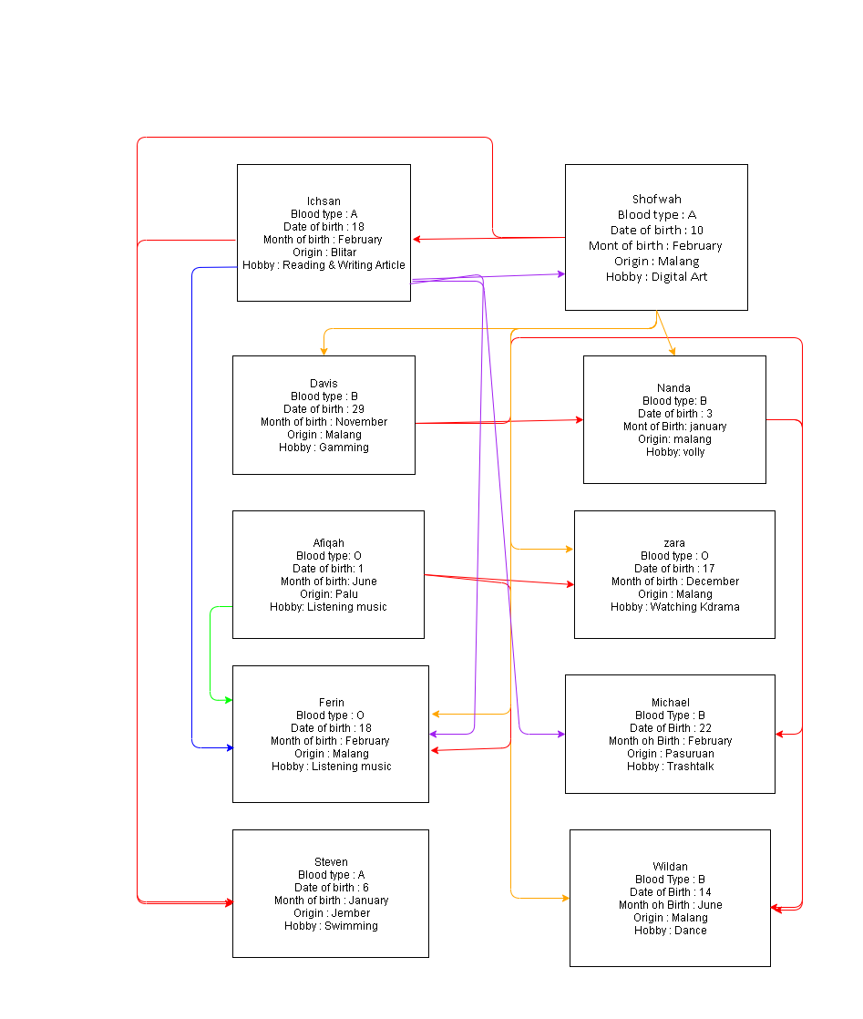

1. **Nanda, Davis, Michael, Wildan**
2. **No one, because my month birth is August.**
3. **No one, because my birth date is 24.**
4. **No one, because I from Surabaya.**
5. **Ichsan and Steven, because my hobby is reading and swimming.**
6. **Input :price every 1kg Rp4.500, ani 4kg, budi 15kg, bina 2kg, cita 11kg.**

**Process :**

* **First, search known data.**
* **Then calculate for all customers.**
* **Ani = 4 * 4.500 = Rp18.000**
* **Budi = 15 * 4.500 = Rp67.500 * 5 % = 67.500 – 3.375 = Rp64.125**
* **Bina = 2 * 4.500 = Rp9.000**
* **Cita = 11 * 4.500 = Rp49.500 * 5 % = 49.500 - 2.475 = Rp47.025**
* **Total = 18.000 + 64.125 + 9.000 + 47.025 = Rp138.150**

**Output : Total income**